**BIRLA INSTITUTE OF TECHNOLOGY & SCIENCE, PILANI WORK INTEGRATED LEARNING PROGRAMMES**

Cloud Computing (CSI ZG527 / SS ZG527 / SE ZG527) Second Semester 2020-2021

Assignment

|  |  |  |
| --- | --- | --- |
| Name | : | Mohammad Arif |
| Student No | : | 2020MT93541 |
| Assignment | : | Develop and deploy a simple web application-based login form using either Google App  Engine or Microsoft Azure or AWS (Amazon Web Service) Elastic Beanstalk. This  application should accept the username and password and then display a message “Login  Successfully” after successful validation. Otherwise, display “Login failed due to incorrect  username and password”. This application can be implemented using any programming  language of your choice (HTML with Python, Java, etc.). |

**Solution:**

*This project was developed using Javascript and deployed on Azure, username and password and then display a message “Login Successfully” after successful validation. Otherwise, display “Login failed due to incorrect*

*username and password”*

**Login Successful scenario:**

Step1 : Go to the URL - <https://white-moss-016baf30f.azurestaticapps.net/index.html>

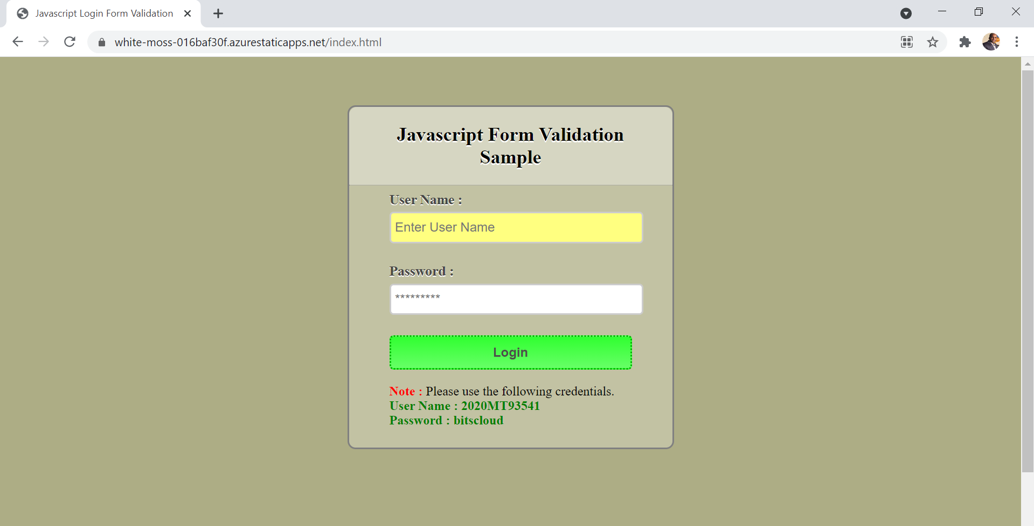

Step 2: Enter correct login and password and click on login

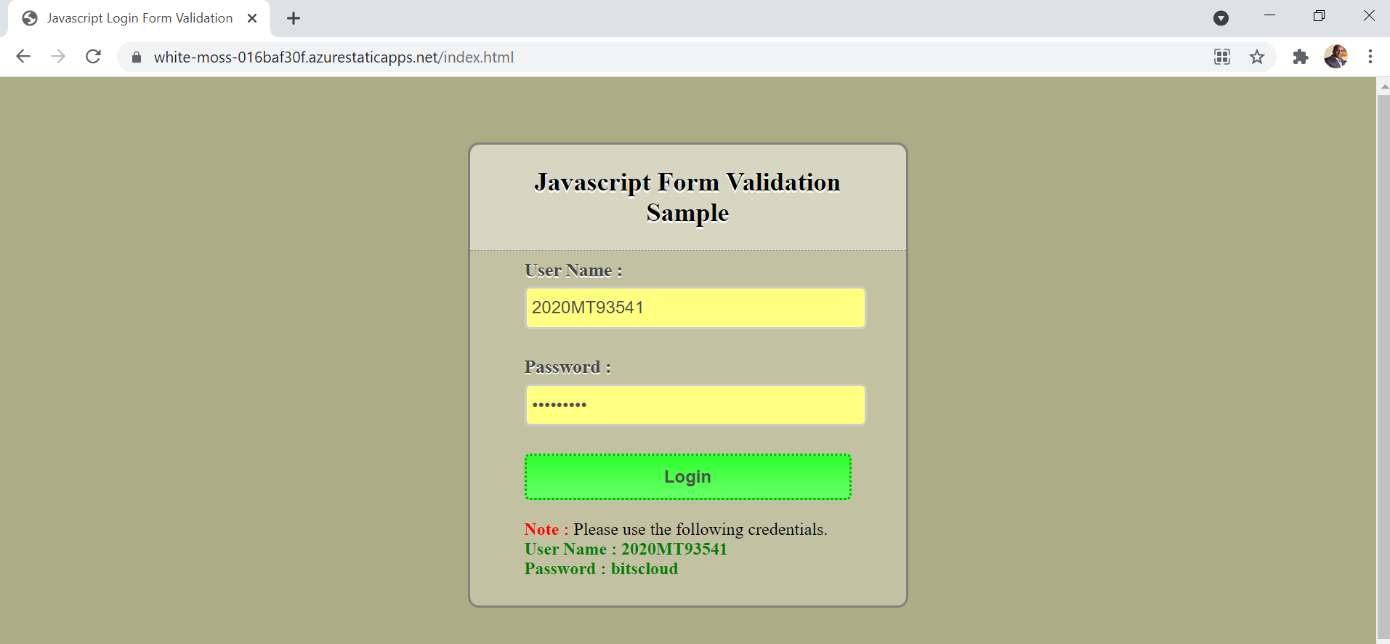

Alert will be displayed as below for login successful:

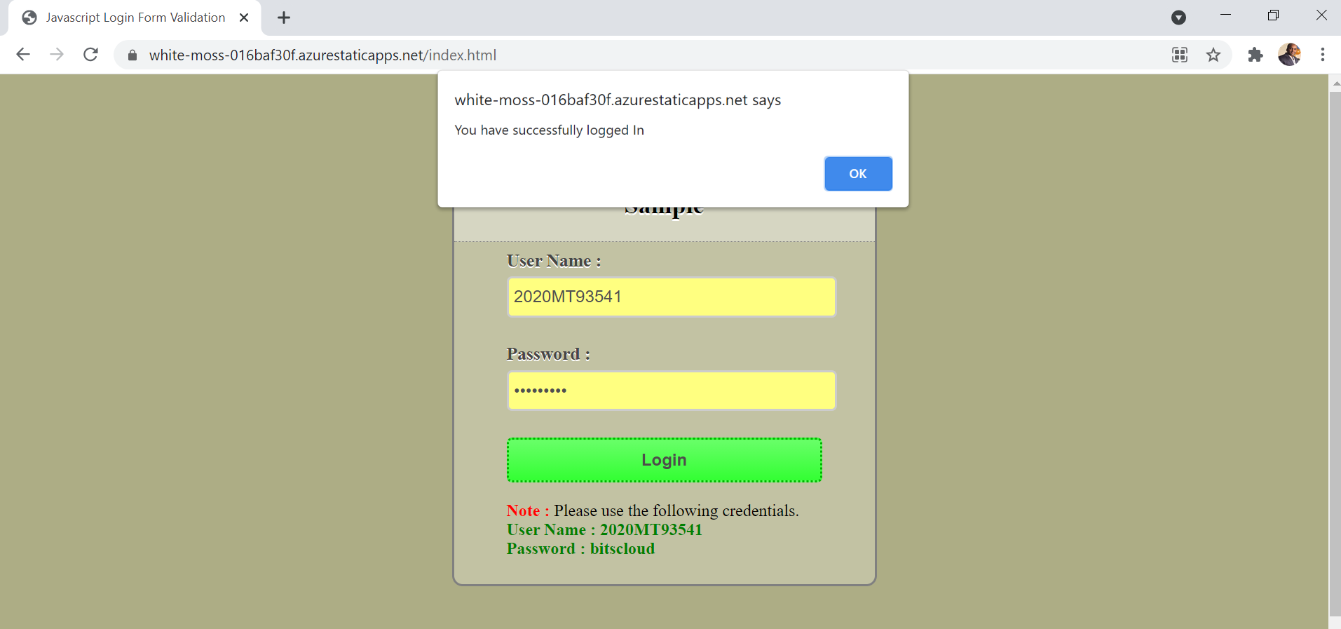

Step 3: Click ok

Below welcome screen will be displayed

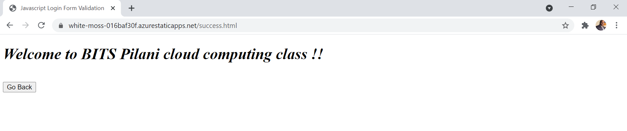

**Login failed due to incorrect username and password scenario:**

Step1 : Go to the URL - <https://white-moss-016baf30f.azurestaticapps.net/index.html>



Step 2: Enter incorrect login and password and click on login

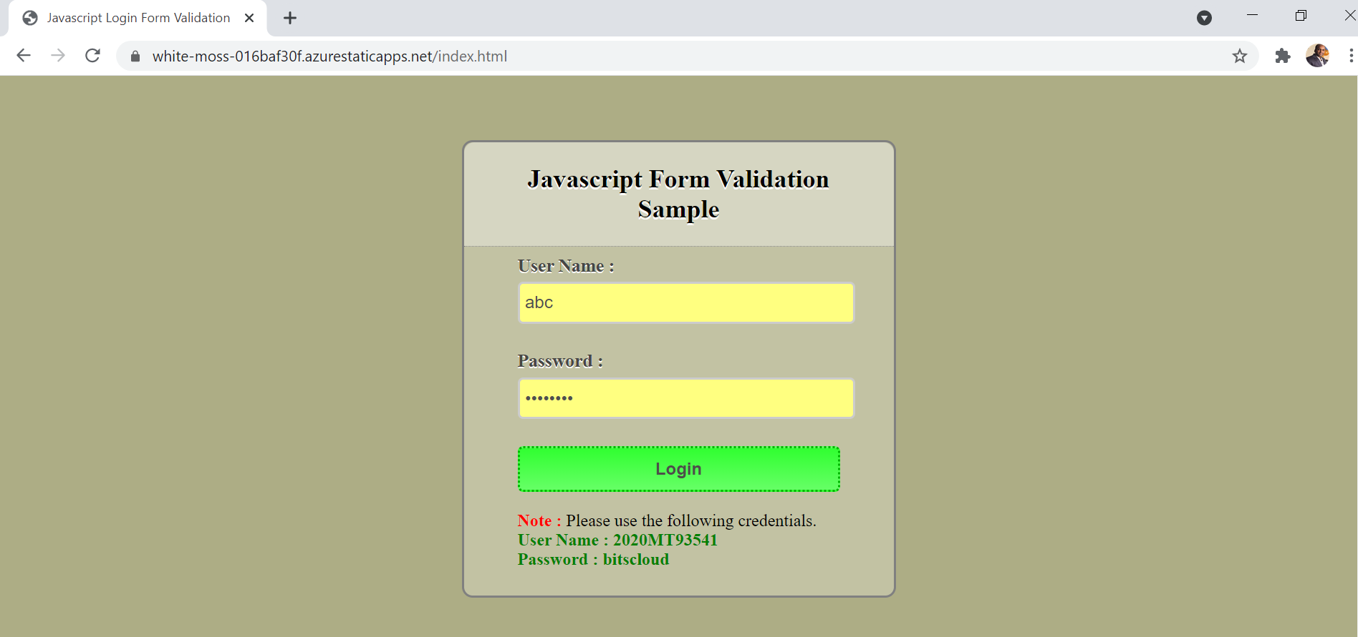

Alert Message displayed as login failed due to incorrect username and password

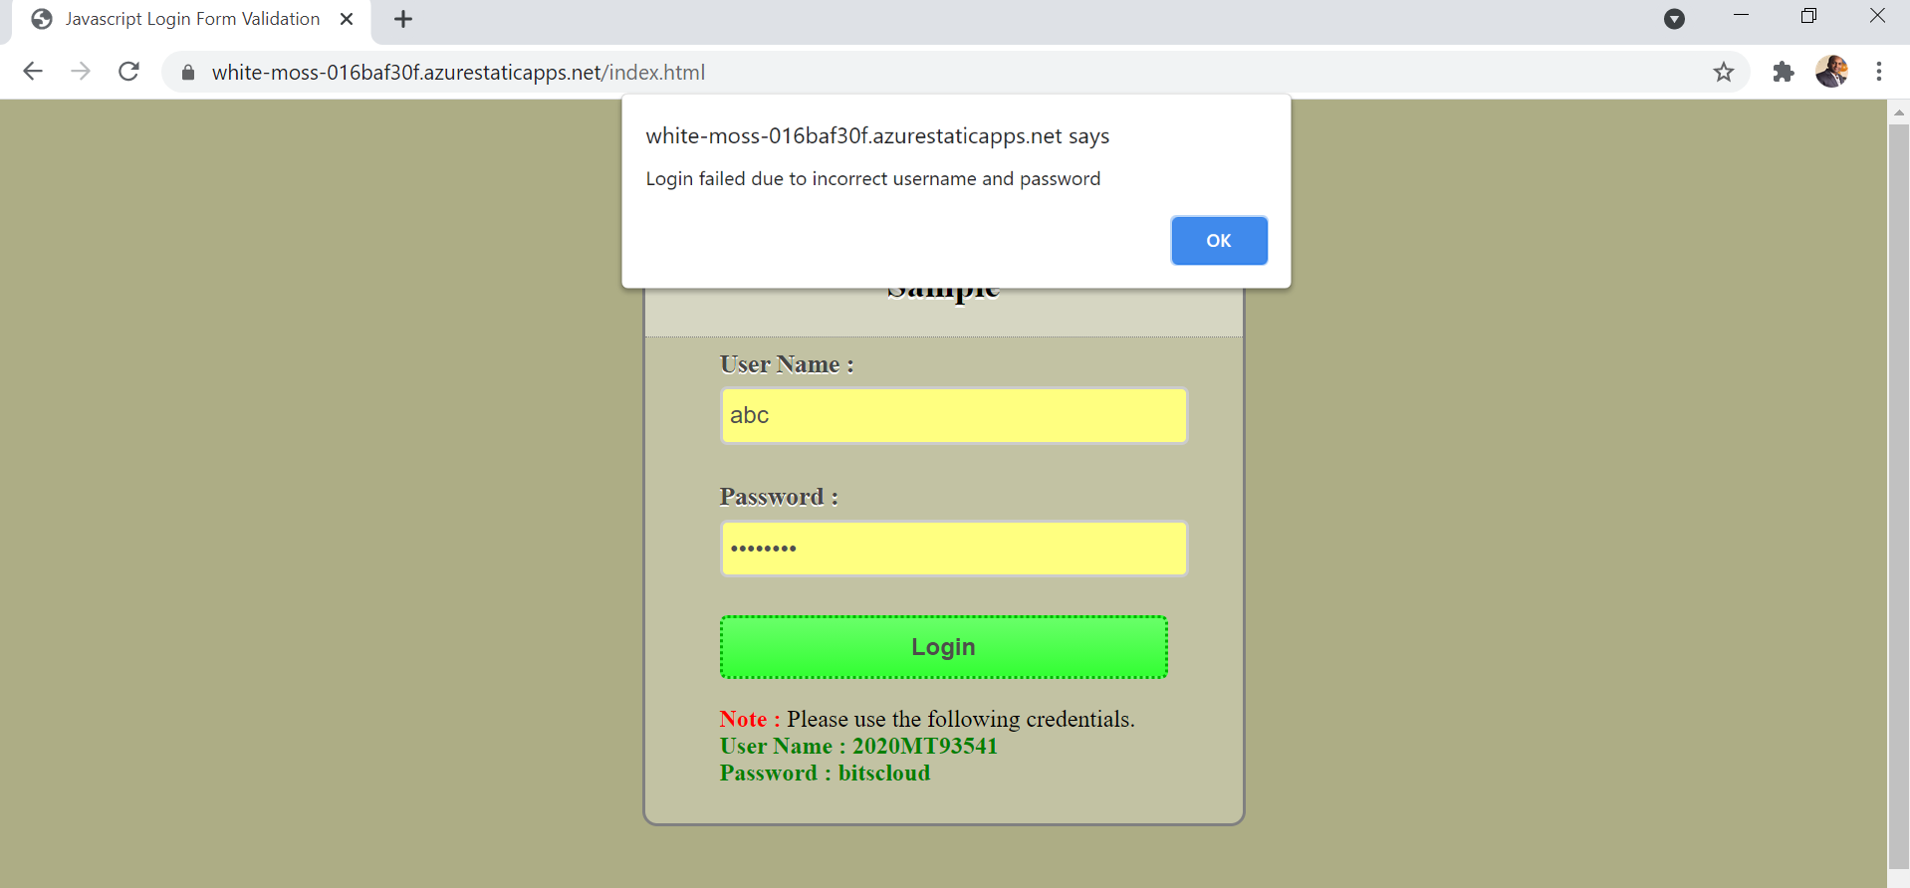

The code can also be found on GITHUB:

<https://github.com/mdarif055/Log-In-Form-Validation-Using-JavaScript>